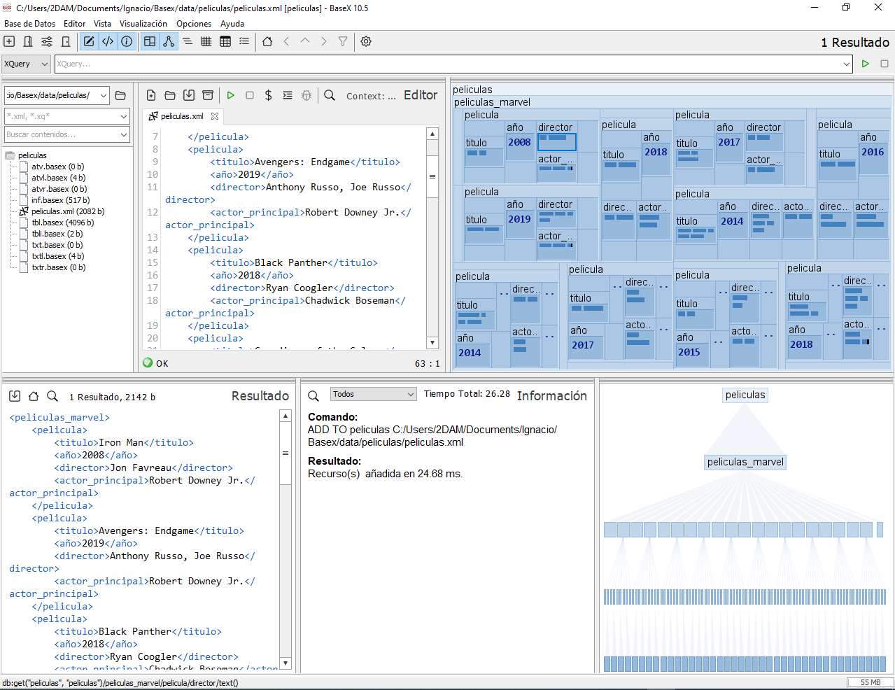

1 xpath

//pelicula[año > 2010 and año < 2016]/titulo/text()

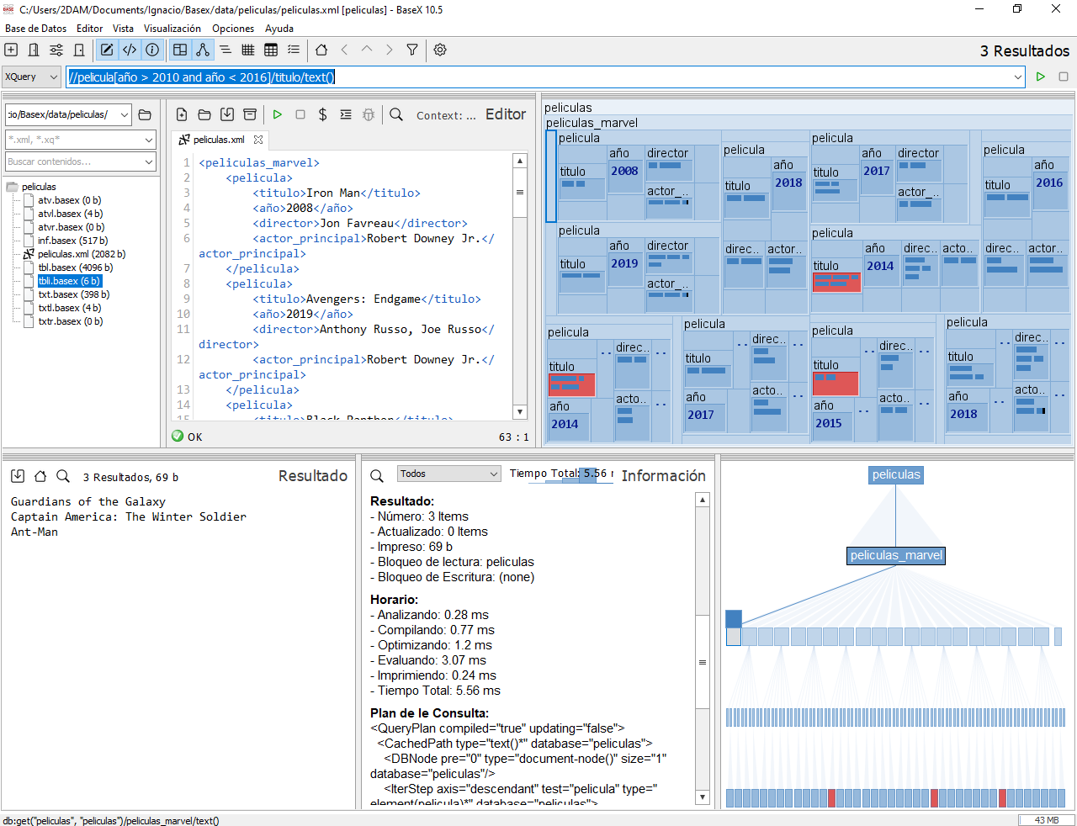

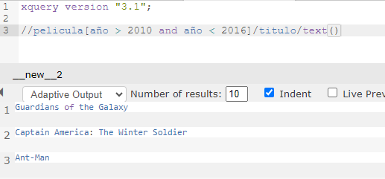

2 xpath

//pelicula[director = 'James Gunn']/titulo/text()

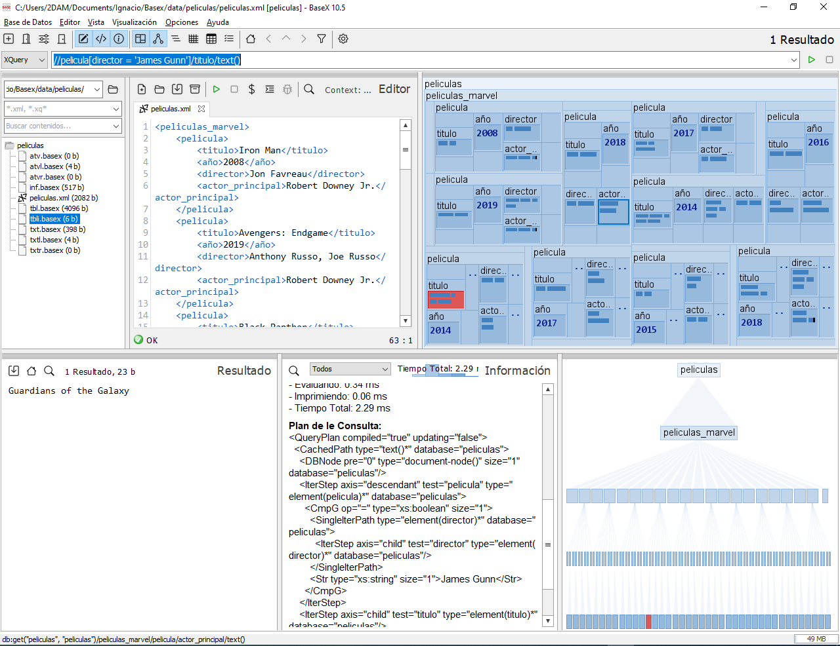

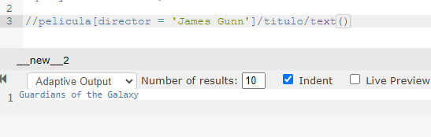

1 xquery

for $pelicula in /peliculas_marvel/pelicula

where $pelicula/año < 2010

return $pelicula/titulo/text()

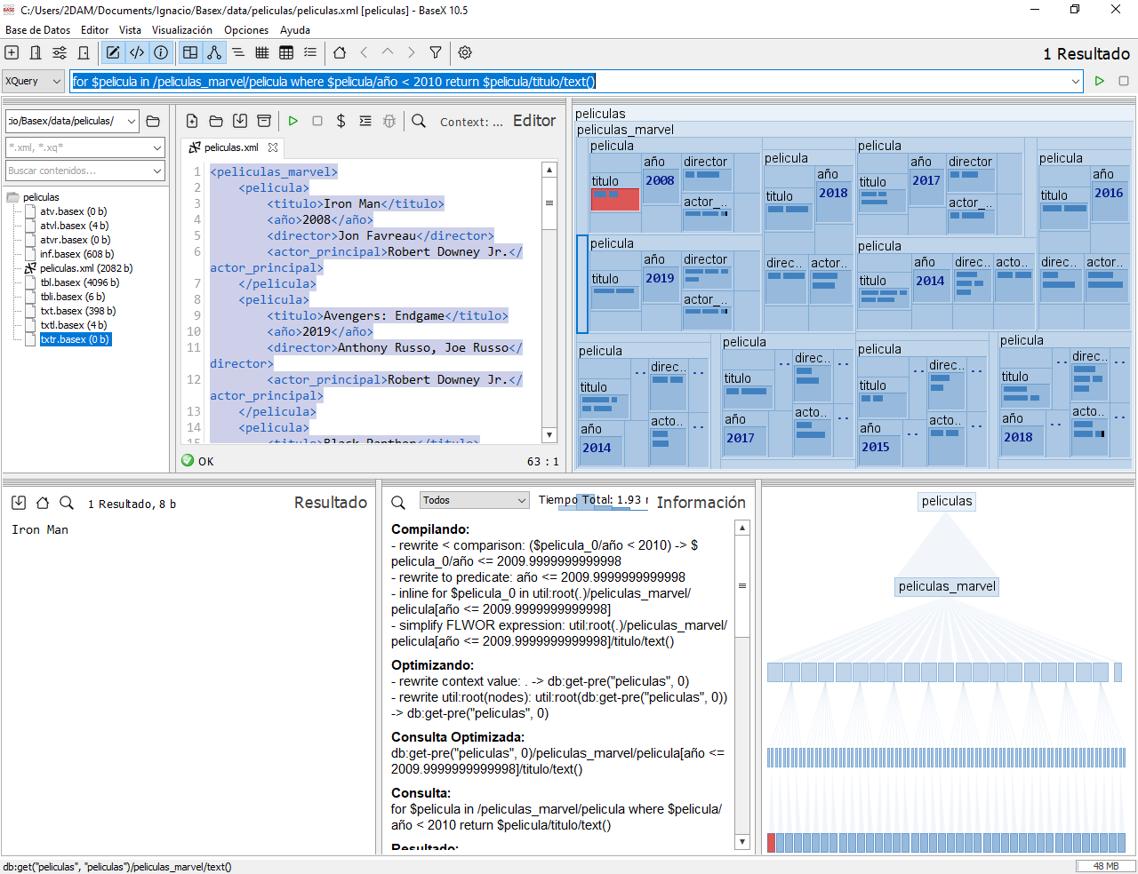

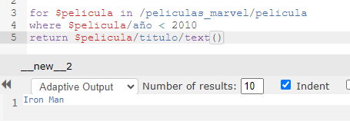

2 xquery

for $pelicula in /peliculas_marvel/pelicula

where $pelicula/actor_principal = 'Chris Evans'

return $pelicula/titulo/text()

